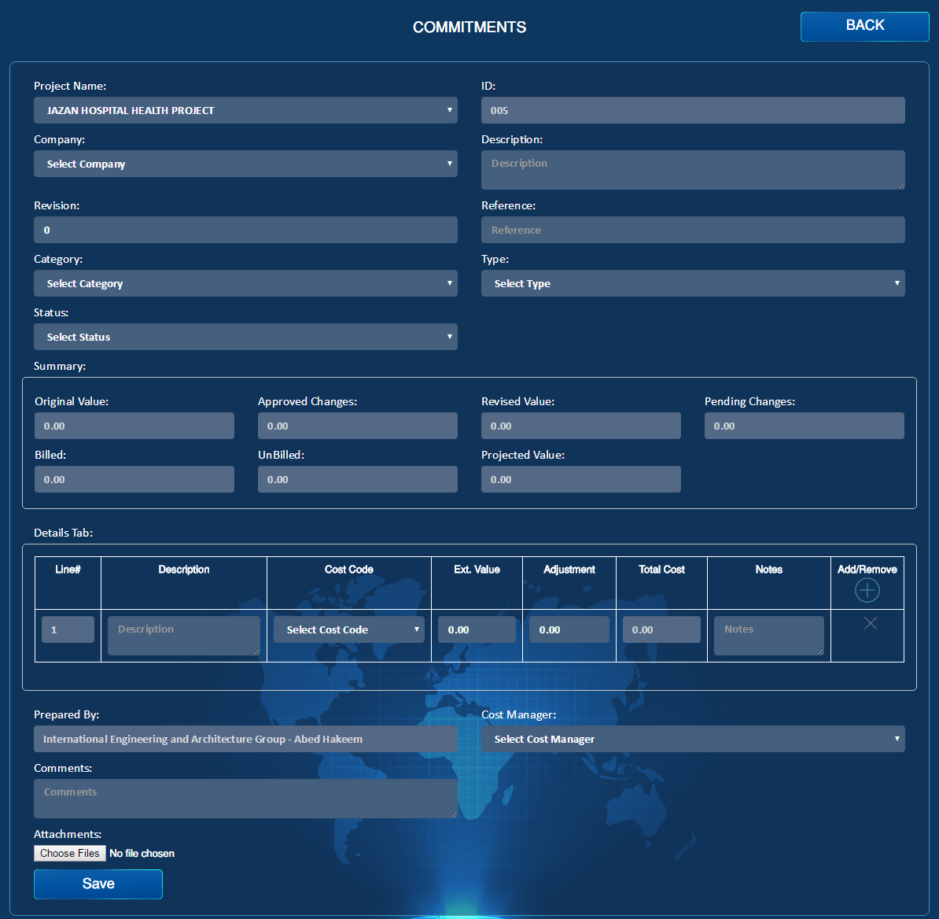

Contract #

**Delivery Information Box**

Import

Draft

Import

Reject

Import

Approve

Import

Show Links

Import

**Effective Date**

Import

Import

Import

Create Payment

Import

Create Change Order

Import

Transmittal Letter

Import

Email

Import

PDF

Import

MR #

Import

PO#

Import

Submit

Import

Original Value

Export

Import

Re-name to “Contracts”

1. Create Change order & Create Payment buttons should be there.
2. Category should include:
3. Contract
4. Subcontract
5. Purchase order
6. Consultations
7. PDF & Email.
8. Transmittal Letter
9. PO# & MR# should be mandatory if the Category of contract was Purchase Order.
10. Submit & Draft should be there
11. Export & Import for the detailed table should be there.
12. Delivery information Box to be added, this box will be active if the type of contract is purchase order otherwise it will be disabled:

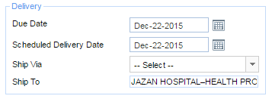

1. Billing Condition box to be added, this is used to control the payment part which will include the following:

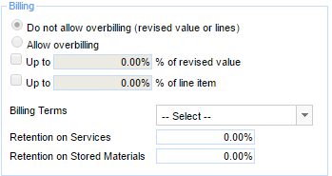

1. Effective date of contract to be added
2. Show Links Tab should be there, the connected Reports are:

(NCR, SWI, Change Order)

1. Approve & Reject will be choices for the responder who is the cost Manager.
2. Revision Concept should be the same as all reports, after the creator will edit the form then he has a message box if he wants to change the revision( so the process will be semi-Manual)

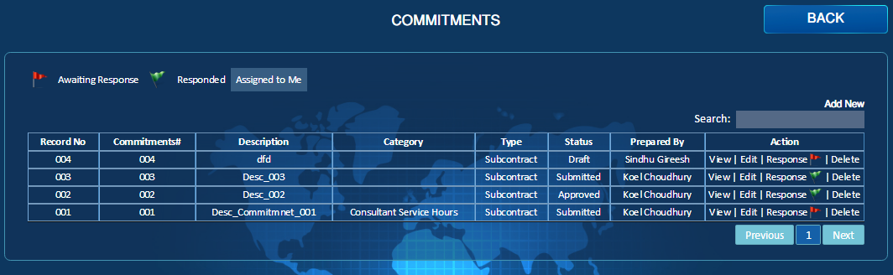

Re-name to “Contracts”

Draft

Import

No Action Required

Import

Action Require

Import

Category

Import

1. In the list page filter by Category is required